CS1428 Lab 12h

# Name: Section:_____________________

This week we will be deviating from our C++ and diving into the *magical* world of Perl.

The goal for this lab is to get you familiarized in Perl and write a very basic script to parse RSS feeds that you select and display them on a web page. This lab will also count as a quiz grade.

A quick history of Perl:

**Perl** is a family of [high-level](http://en.wikipedia.org/wiki/High-level_programming_language), [general-purpose](http://en.wikipedia.org/wiki/General-purpose_programming_language), [interpreted](http://en.wikipedia.org/wiki/Interpreter_(computing)), [dynamic programming languages](http://en.wikipedia.org/wiki/Dynamic_programming_language). The languages in this family include Perl 5 and [Perl 6](http://en.wikipedia.org/wiki/Perl_6).

Though Perl is not officially an acronym, there are various [backronyms](http://en.wikipedia.org/wiki/Backronym" \o "Backronym) in use, such as: *Practical*[*Extraction*](http://en.wikipedia.org/wiki/Data_extraction)*and Reporting Language*. Perl was originally developed by [Larry Wall](http://en.wikipedia.org/wiki/Larry_Wall) in 1987 as a general-purpose [Unix](http://en.wikipedia.org/wiki/Unix) scripting language to make report processing easier. Since then, it has undergone many changes and revisions. The latest major stable revision of Perl 5 is 5.18, released in May 2013. [Perl 6](http://en.wikipedia.org/wiki/Perl_6), which began as a redesign of Perl 5 in 2000, eventually evolved into a separate language. Both languages continue to be developed independently by different development teams and liberally borrow ideas from one another.

The Perl languages borrow features from other programming languages including [C](http://en.wikipedia.org/wiki/C_(programming_language)), [shell scripting](http://en.wikipedia.org/wiki/Shell_script) ([sh](http://en.wikipedia.org/wiki/Bourne_shell" \o "Bourne shell)), [AWK](http://en.wikipedia.org/wiki/AWK_(programming_language)), and [sed](http://en.wikipedia.org/wiki/Sed). They provide powerful text processing facilities without the arbitrary data-length limits of many contemporary [Unix command line tools](http://en.wikipedia.org/wiki/Unix_commandline_tools), facilitating easy manipulation of [text files](http://en.wikipedia.org/wiki/Text_file). Perl 5 gained widespread popularity in the late 1990s as a [CGI scripting](http://en.wikipedia.org/wiki/Common_Gateway_Interface) language, in part due to its [parsing](http://en.wikipedia.org/wiki/Parsing) abilities.

In addition to CGI, Perl 5 is used for [graphics programming](http://en.wikipedia.org/wiki/Computer_graphics_(computer_science)), [system administration](http://en.wikipedia.org/wiki/System_administrator), [network programming](http://en.wikipedia.org/wiki/Computer_network_programming), finance, [bioinformatics](http://en.wikipedia.org/wiki/Bioinformatics), and other applications. It is nicknamed *"the Swiss Army chainsaw of scripting languages"* because of its flexibility and power, and possibly also because of its perceived "ugliness". In 1998, it was also referred to as the *"*[*duct tape*](http://en.wikipedia.org/wiki/Duct_tape)*that holds the Internet together",* in reference to its ubiquitous use as a [glue language](http://en.wikipedia.org/wiki/Glue_language) and perceived inelegance.

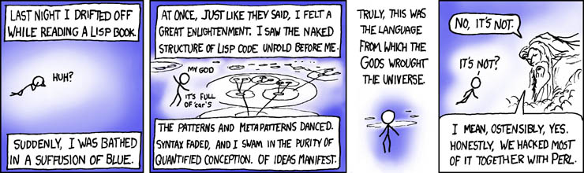

For this assignment you will need these things modules:

use XML::RSS::Parser::Lite;

use LWP::Simple;

You will need these arrays:

* One to hold the RSS URLs
* One to hold the articles

You will need these loops

* One to parse through all of the URLs
* One to parse through all articles in each URL

You will have to pull the attributes from the XML

* Title (‘title’)
* Description (‘description’)
* URL (‘url’)
* Time (‘pubDate’)

You need to push into the articles array an anonymous hash containing the above attributes, plus one more.

You will need one more loop to iterate through the articles array and print the proper links in HTML

You will need my two subroutines from the snippets file.

**Try your best to do this alone, but if you get lost let me know IMMEDIATELY!!!!**

**Don’t just sit there and stare at the screen.**

**I know this is new and complicated, but you have the ability to learn it and this is what you will see in the real world.**